EENG 385 - Electronic Devices and Circuits

BJT Curve Tracer: Calibration

Lab Solutions

# Overview

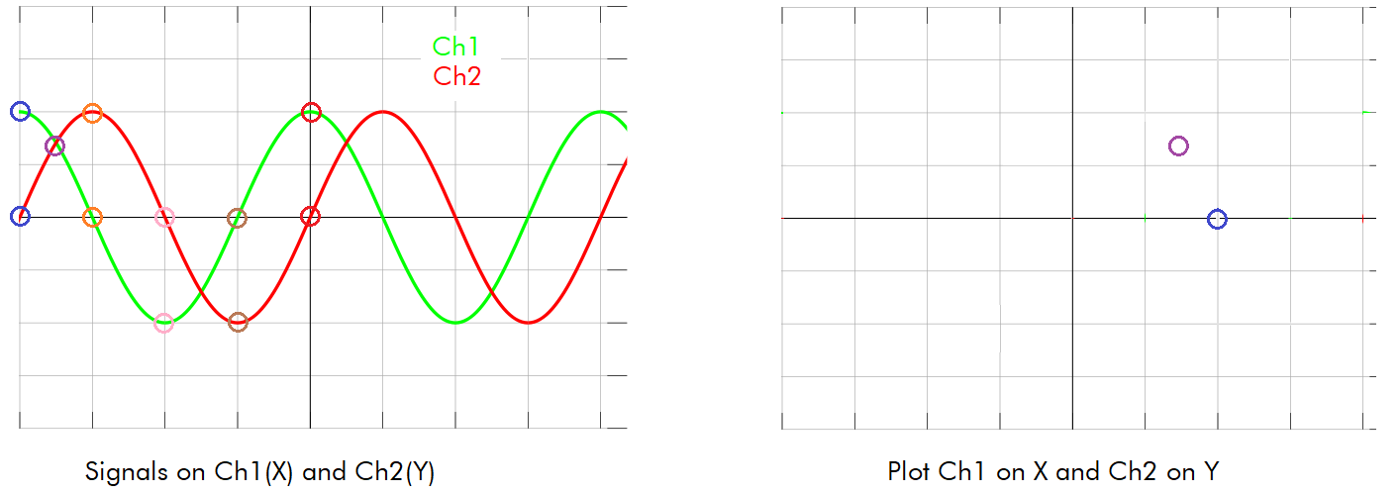

Figure : A pair of signals on Channel 1 and 2. Plot these 2 signals in XY mode.

**Forms a circle**

Table : The X,Y values of the curve in Figure 3.

|  |  |  |
| --- | --- | --- |
| Time | Ch 1 (X) | Ch 2 (Y) |
| Blue | 2 | 0 |
| Purple | 1.4 | 1.4 |
| Orange | 0 | 2 |
| Pink | -2 | 0 |
| Brown | 0 | -2 |
| Red | 2 | 0 |

**Each Curve – Base Current**

Table : The base current for each step of the staircase function created in Lab 3.

|  |  |  |
| --- | --- | --- |
| Trace | VSTAIR | ib (uA) |
| 9 | 8.03 | 15.6 |
| 8 | 7.84 | 15.2 |
| 7 | 6.95 | 13.3 |
| 6 | 6.06 | 11.4 |
| 5 | 5.07 | 9.3 |
| 4 | 4.18 | 7.4 |
| 3 | 3.29 | 5.5 |
| 2 | 2.39 | 3.6 |
| 1 | 1.41 | 1.5 |
| 0 | 0V | 0 |

# Turn in:

Make a record of your response to numbered items below and turn them in to Canvas using the instructions posted there. While you can work together to answer the questions in this lab document, you will work individually, with your own BJT Curve Tracer board, to test 3 BJTs. Thus, everyone is expected to turn in their own document. If you worked with someone, please include their name at the top of your document.

**Oscilloscope in X/Y Mode**

Completed Figure 3.

Completed Table 1.

**Axis Scale for BJT Curve Tracer**

Completed Table 2.

**Completing the BJT Performance Card the BJT**

Complete a BJT Performance Card for the 2N3904 or 2N2222 BJT.

Complete a BJT Performance Card for the BD139 or TIP41C BJT.

Complete a BJT Performance Card for some other NPN BJT you find in the lab. As a first step, find the device datasheet. From this:

* + Find the pinout – Base, Emitter, Collector
  + Find the DC gain at the collector current around the values in Table 3.
  + Compare your calculated gain to the datasheet gain and note this somewhere on the BJT Performance Card.